Covid  Complete,LLC | 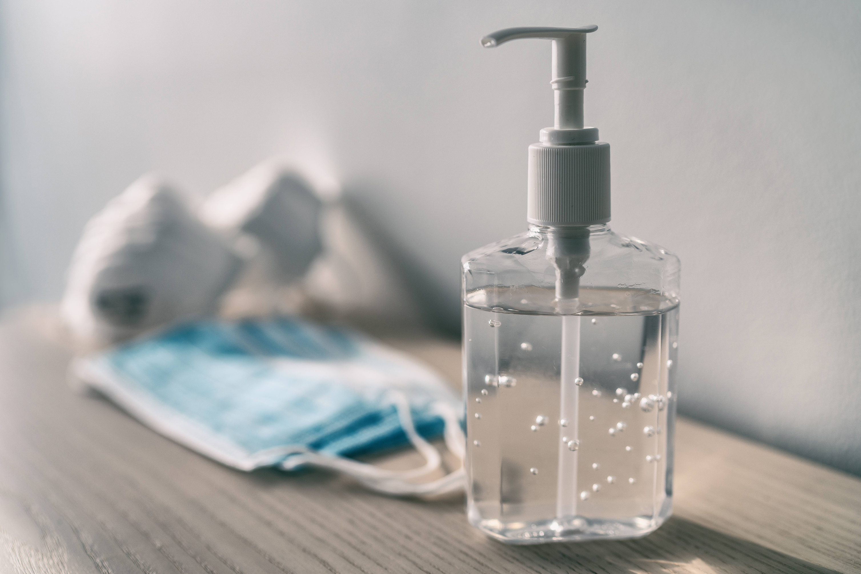
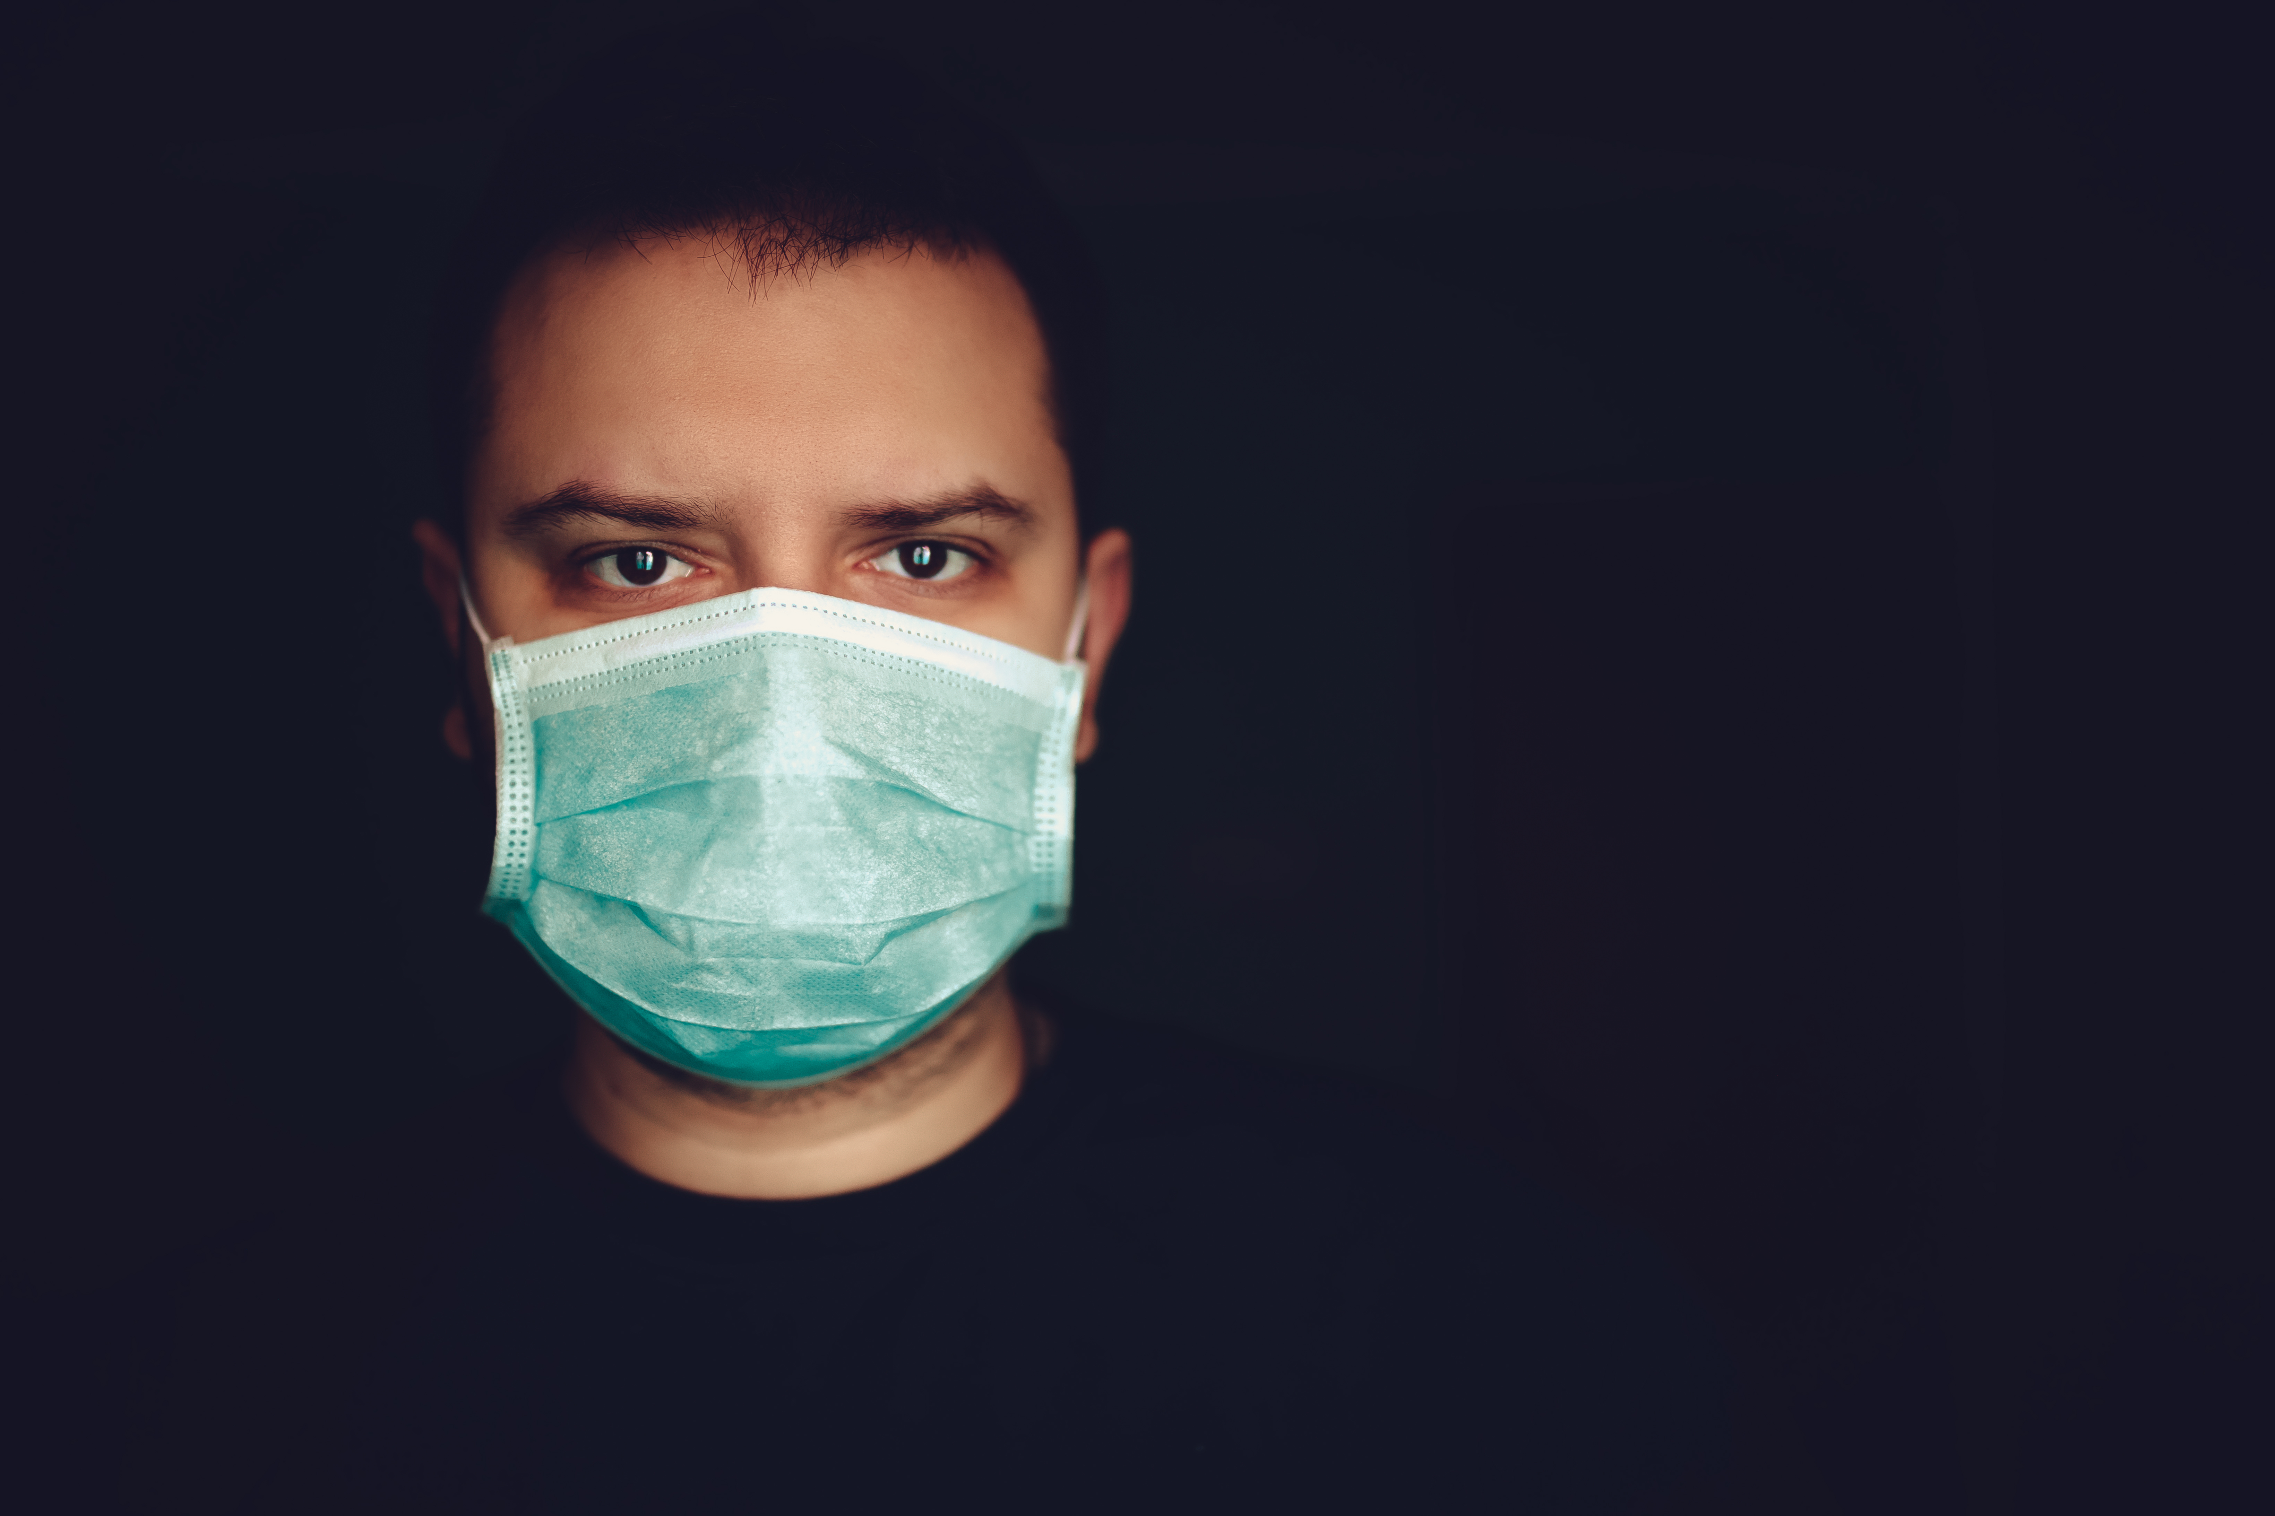 | NON-INVASIVE MOUTH SWABBING

ON-SITE COVID 19 TESTING
Here at Covid Complete we are committed in helping stop this killer virus. Please do YOUR part as well, by getting tested frequently. Even if you are FULLY VACCINATED there is a possibility that you van still come down with COVID-19. Be wise and knowledge by getting TESTED TODAY.

WE OFFER ON-SITE TESTING AT:
- YOUR PLACE OF BUSINESS
- HOME
- YOUR EVENT(S)
- PLACE OF WORSHIP
- FAMILY GATHERING
THERE IS NO COST FOR OUR TESTING-WE SERVE INDIVIDUALS WITH OR WITHOUT INSURANCE (SOME RESTRICTIONS APPLY)

THESE ARE SOME OF THE GROUPS THAT SHOULD GET TESTED:
- PARTICIPATION IN SPORTS PROGRAM REQUIRE TESTING BEFORE GAMES
- PEOPLE WHO HAVE SYMPTOMS OF COVID-19
- PEOPLE WHO ARE NOT FULLY VACCINATED, OR NOT VACCINATED
- IT IS RECOMMENDED THAT EMPLOYERS WITH 100+ WORKERS ENSURE THEIR WORKERS ARE VACCINATED OR TESTED WEEKLY
- PEOPLE WHO HAVE COMPROMISED IMMUNE SYSTEMS
- PEOPLE THAT ARE TRAVELING
Contact Information
832-429-6244
Covidcomplete@gmail.com

WHAT WE PROVIDE:

NON-INVASIVE MOUTH SWAB-PAIN FREE FAST AND CONVENIENT

TRAVEL FRIENDLY-OUR PCR TESTS RESULTS ARE ACCEPTED FOR INTERNATIONAL AND DOMESTIC TRAVEL

FAST RESULTS-OUR RESUTS ARE PROVIDED VIA EMAIL WITHIN 12-24 HOURS.

